SEO Metadata
- Focus Keyword: best website design company in Bangalore
- Meta Title: Best Website Design Company in Bangalore (2026 Guide) | Brewing Ideaz
- Meta Description: Looking for the best website design company in Bangalore? Learn what to evaluate — UX, visual quality, process, pricing & red flags — before you hire.
- URL Slug: /best-website-design-company-in-bangalore

Secondary Keywords
- website design company in Bangalore
- website designers in Bangalore
- professional website design services Bangalore
- custom website design Bangalore
- responsive website design Bangalore
- website redesign services Bangalore
- UI/UX website design Bangalore
- business website design Bangalore
- ecommerce website design Bangalore
- Brewing Ideaz Bangalore

Internal Linking Suggestions
- /services/ or /website-design/ or /web-design/
- /contact-us/
- /portfolio/ or /case-studies/

Best Website Design Company in Bangalore: A Complete Guide to Choosing the Right Partner
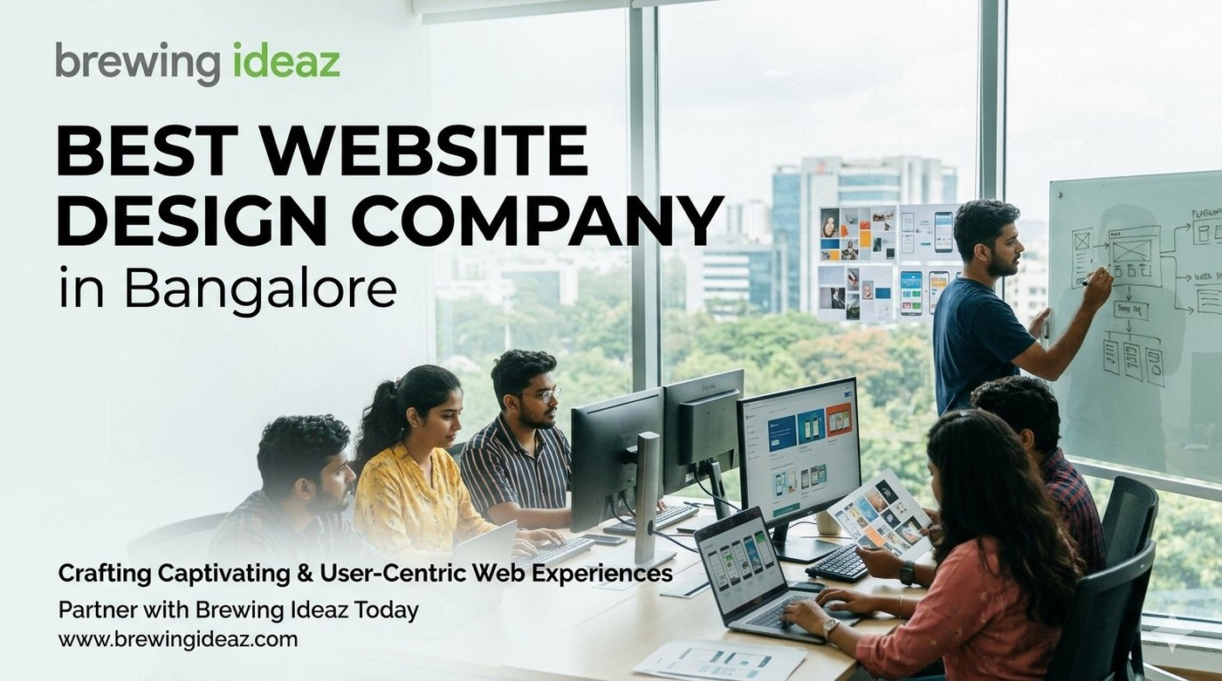
Your website is frequently the first detailed interaction potential customers and partners have with your brand. In Bangalore’s competitive environment, many studios market themselves as the “best website design company in Bangalore.” Visual quality, user experience thinking and execution reliability vary widely. This guide gives you a practical evaluation framework.

What “Best” Means in Website Design
A strong website design company creates sites that are visually coherent, easy to use, fast, mobile-friendly and aligned with business goals. The best partners combine user research, information architecture, visual design and close collaboration with development.
Fit is important. A studio excellent at marketing websites may not be the ideal choice for a complex product interface or large content platform.

Key Factors to Evaluate Before Hiring

Live portfolio quality
Review actual websites on multiple devices. Assess clarity, speed and how design supports conversion or engagement goals.

UX and research approach
Strong teams invest time understanding users and journeys before designing screens.

Design system thinking
Look for consistency, scalability of the design language, and clear hand-off practices.

Process and collaboration
Understand discovery, wireframing, visual design, feedback rounds and developer collaboration.

Post-launch considerations
Clarify training, minor adjustments period and ongoing support options.

Ownership
Confirm you receive complete design files and full rights to the final website.

Why Bangalore-Based Website Design Companies Often Excel
Local teams share working hours with most clients, understand the city’s startup and enterprise mix, and are used to iterating quickly with marketing and product stakeholders.

Questions to Ask Before You Hire
- Can you walk me through your discovery and design process?
- Do you have live examples close to my project type?
- How do you collaborate with developers or handle front-end implementation?
- What is a realistic timeline and how are revisions handled?
- What support do you provide after the site launches?

Red Flags to Watch For
Be cautious of companies that show only static mock-ups, promise unrealistically short timelines for meaningful projects, cannot explain their process, or price significantly below market without transparent scope.

Final Thoughts
The best website design company in Bangalore for your business is the one that understands your users and goals, designs with both aesthetics and usability in mind, and delivers a site that is maintainable and effective.

Ready to Discuss Your Website Project?
Brewing Ideaz is based in Bengaluru (Sarjapur – Marathahalli Road) with a branch office in Kolkata.
Call or WhatsApp: (+91) 62915 47048 Email: info@brewingideaz.com

30 Frequently Asked Questions About Website Design Company in Bangalore
- What is a website design company? A website design company creates and designs websites based on a business’s goals, target audience, and requirements. Services may include visual design, UX, responsive layouts, and development.
- How do I choose the best website design company in Bangalore? Evaluate the company’s portfolio, design expertise, technical capabilities, project process, pricing, communication, and post-launch support.
- What services does a website design company provide? Website design, responsive design, UI/UX design, website redesign, landing page design, and website development.
- How much does a website design company in Bangalore charge? Pricing depends on complexity, features, design requirements, technology, and project scope.
- Why should I hire a professional website design company? To create a website aligned with your business goals that provides a consistent user experience across devices.
- What is the difference between website design and web development? Website design focuses on layout, visual appearance, and UX. Web development implements the design and builds the functionality.
- What is UI/UX design? UI design focuses on visual and interactive elements. UX design focuses on usability, navigation, and user needs.
- Why is responsive website design important? It allows a website to adapt to different screen sizes and devices.
- What is website redesign? Updating a website’s appearance, structure, UX, or functionality to better meet current needs.
- How long does it take to design a website? Depends on complexity, pages, features, content readiness, feedback, and testing.
- What should I prepare before hiring a website design company? Business goals, target audience, requirements, branding assets, content, budget, and timeline.
- What is a website wireframe? A simplified visual layout showing page structure, content placement, navigation, and key elements.
- What is a website prototype? An interactive or visual representation of a website demonstrating user flows before final development.
- What is the role of user experience in website design? How easily and effectively visitors can navigate and complete their intended tasks.
- Why is website loading speed important? A fast-loading website contributes to a better overall user experience.
- What is mobile-friendly website design? Design that ensures usability on smartphones, with readable text and accessible navigation.
- What is accessibility in website design? Designing so people with different abilities can use the site, including keyboard navigation and assistive technologies.
- What is a content management system (CMS)? Software that lets users create, manage, and update content without editing code directly.
- What is the difference between a custom website and a template-based website? A custom site is built to specific requirements; a template site uses a pre-designed layout with limited customisation.
- What is website maintenance? Ongoing updates, backups, security checks, bug fixes, and content updates.
- Will I own my website after the project is completed? Depends on the contract — clarify ownership of code, design files, content, domain, and third-party assets.
- What is included in a website design project? Discovery, wireframes, visual design, responsive layouts, development, testing, launch, and training, depending on scope.
- How do I evaluate a website design company’s portfolio? Review live websites, mobile usability, visual consistency, navigation, performance, accessibility, and relevance.
- Can a website design company help with SEO? Yes — SEO-friendly structures, responsive layouts, and clear navigation; ongoing SEO may require separate services.
- What is conversion-focused website design? Design aimed at helping visitors complete desired actions, such as submitting a form or making a purchase.
- What is the importance of website navigation? Clear navigation helps visitors find relevant information with less effort.
- What should I include in a website design contract? Scope, deliverables, timelines, fees, payment terms, revision limits, ownership, and post-launch support.
- What are common mistakes to avoid when hiring a website design company? Choosing solely on price, ignoring mobile usability, failing to define scope, overlooking ownership terms, neglecting post-launch support.
- Does a website design company guarantee website performance? A company may agree to specific technical requirements, but actual performance also depends on hosting, content, and integrations.
- How can I contact Brewing Ideaz for website design services in Bangalore? Call or WhatsApp +91 62915 47048 or email info@brewingideaz.com.

